HOSTING DEEPSEEK AND FLASK-BACKEND WITH DOCKER AND EC2

STEPS WE NEED TO FOLLOW-
On Local -
- Pull the image from github repo
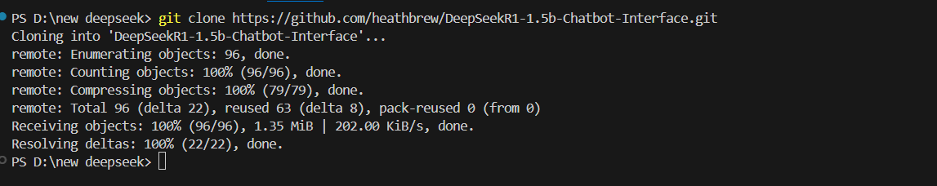
- Try to run locally by creating python venv
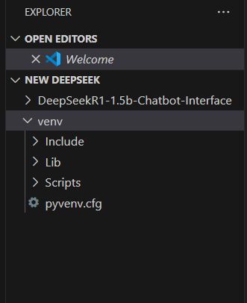
- Install requirements.txt
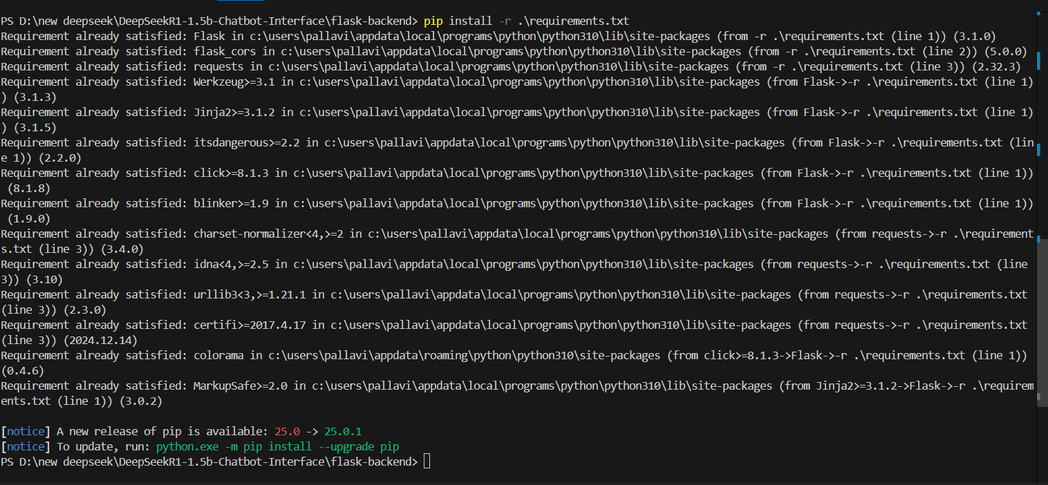
- Try to run python app.py
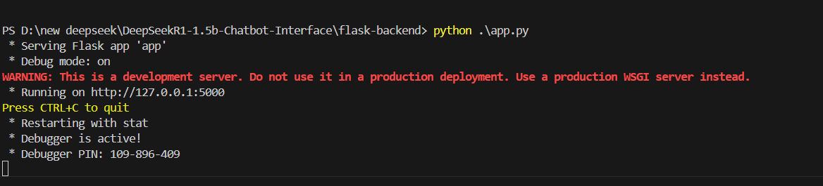
On Docker –
- Now try to write a Dockerfile in which you need to add all the processes required to run docker image. Below os my Dockerfile with start.sh file

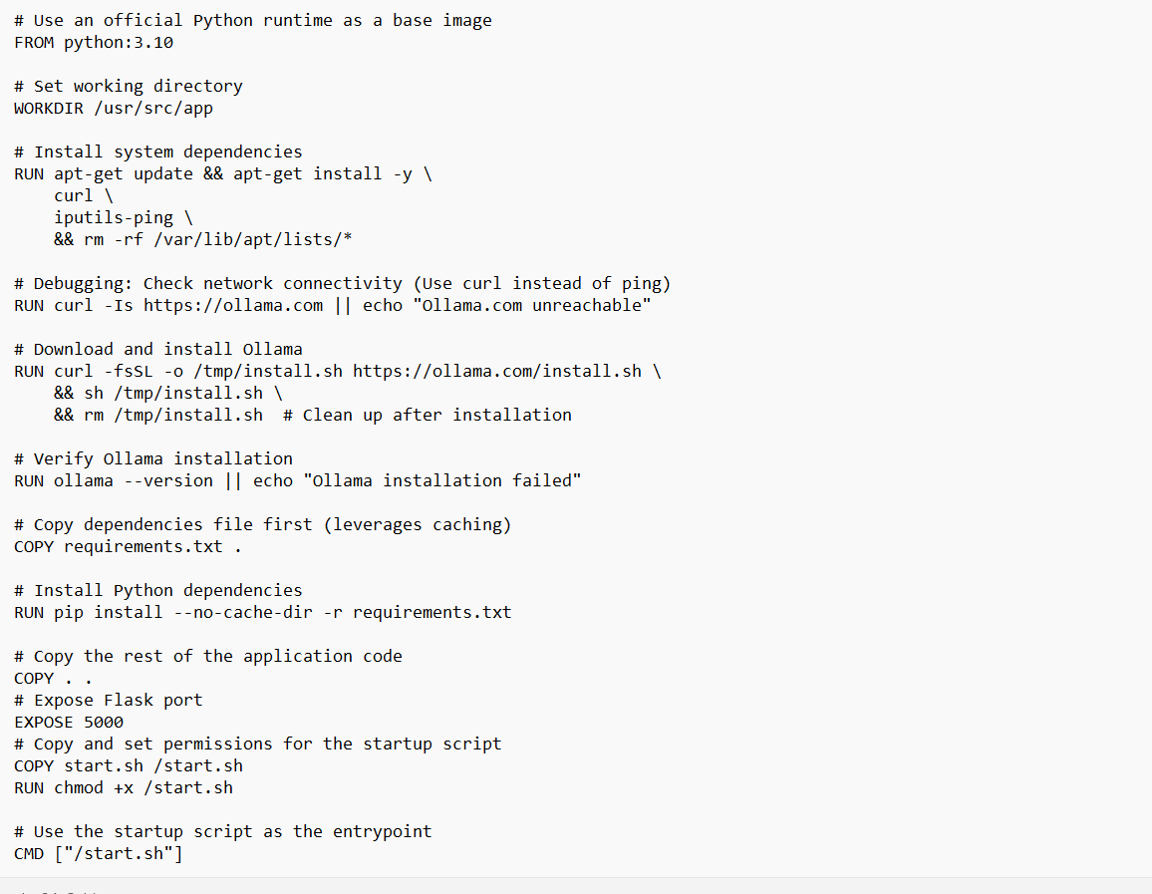

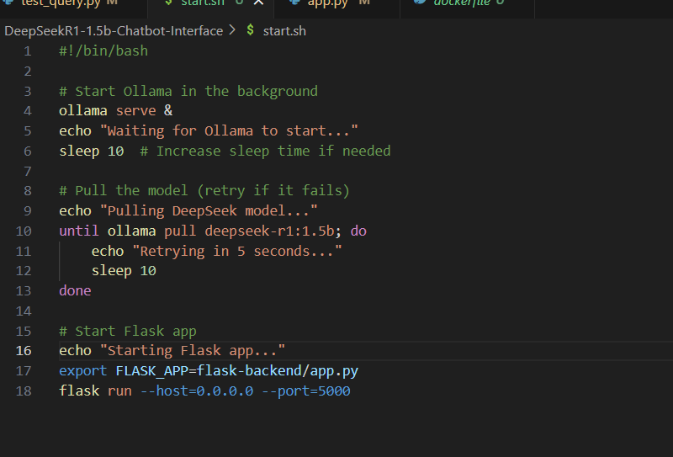

- Try to build the image out of Dockerfile by using
docker build –t your-image-name

- Try to run the caontainer out of the image you made
docker run –d –p 5000:5000 your-image-name

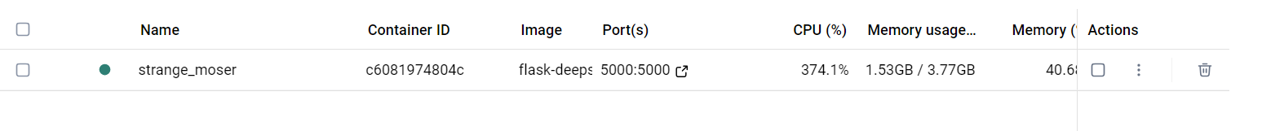
Make sure container is running

- Try to access the localhost URL from Postman. Here we are accessing localhost url because we
Have mapped our docker caontainer with it. Please see below image to see how it looks.

How it looks from local -

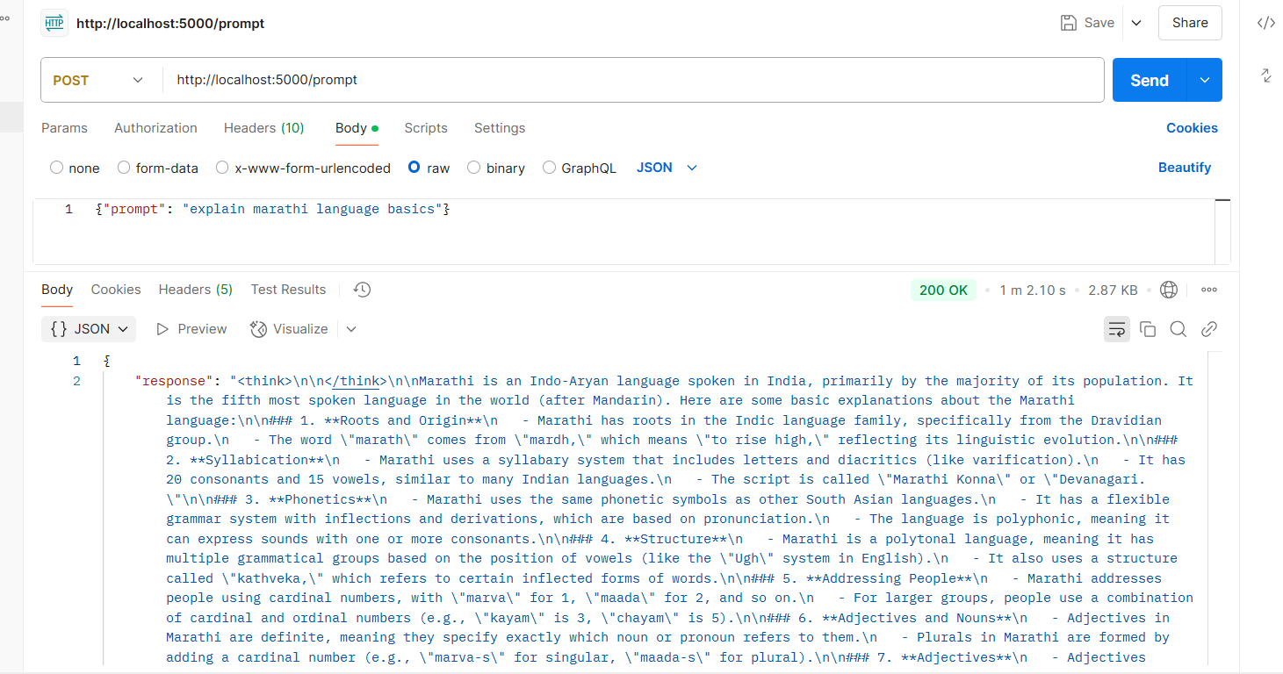

Push docker image to ECR-
Now we need to push the image to ECR
- Aws configure- add access key, secret access key, region etc
- Create ECR repo on aws account.
- Use following command step by step

aws ecr get-login-password --region us-east-1 | docker login --username AWS --password-stdin 920373003665.dkr.ecr.us-east-1.amazonaws.com

docker tag flask-deepseek:latest 920373003665.dkr.ecr.us-east-1.amazonaws.com/flask-deepseek:latest

docker push 920373003665.dkr.ecr.us-east-1.amazonaws.com/flask-deepseek:latest

- Check if our image is present in ECR –

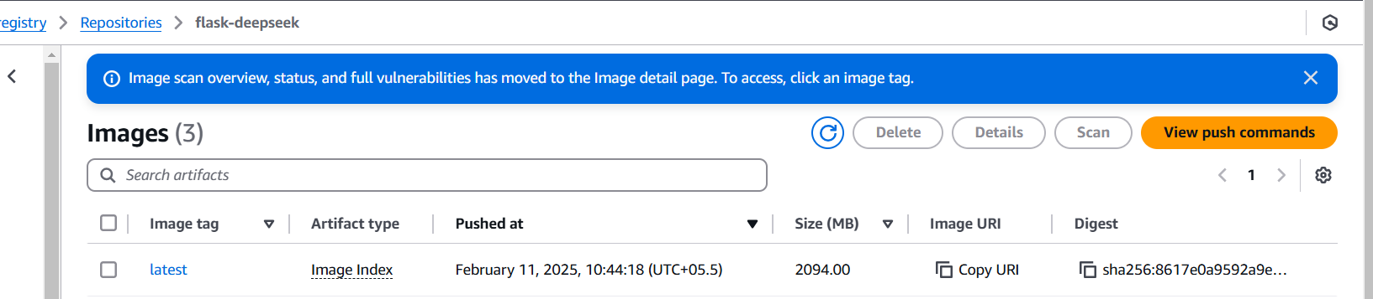

HOST THE DOCKER IMAGE ON EC2-
aws ecr get-login-password --region us-east-1 | docker login --username AWS --password-stdin <your-aws-account-id>.dkr.ecr.us-east-1.amazonaws.com

docker pull <your-aws-account-id>.dkr.ecr.us-east-1.amazonaws.com/my-app:latest

docker run -d -p 80:80 --name my-container <your-aws-account-id>.dkr.ecr.us-east-1.amazonaws.com/my-app:latest

results after deployed on ec2 on postman is below –

